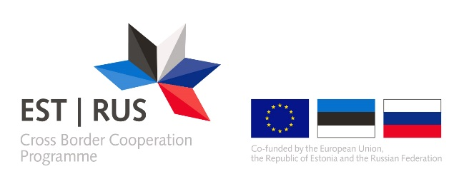
ANNEX 7
DECLARATION OF APPLYING STATE AID / DE MINIMIS AID
Project Partner 2 Tartu City Government
Activity | Total cost of the activity (inc VAT) | Eligible cost of the activity | Aid intensity (%) | Aid amount | State aid / de minimis aid / non-economic activity
No 1 Preparation
No 2 Management
No 3 Core activity
No 4 Investment | 961 500 | 961 500 | 65% | 624 975 | art 55 80%
No 5 Communication
Total | 961 500 | 961 500 | 65% | 624 975 | art 55 80%

Name and position of the signatory | Kunnar Jürgenson  Head of Department of Municipal Property
Location | Tartu, Estonia
Date of signature | 06.2019
Signature and stamp

This declaration is only applicable to the applicants and/or partners from Estonia.
Please indicate which of the following aid regulations you apply: 1) State aid Regulation (EU) No 651/2014 (article 14, 53, 55 or 56); 2) de minimis aid Regulation (EU) No 1407/2013; 3) de minimis aid Regulation (EU) No 717/2014. If the activity is marked as non-economic please justify briefly why this activity is not State aid relevant according to the points 2-7 of the State aid guidelines for the large infrastructure projects of the Estonia-Russia cross border cooperation programme 2014-2020.

